**University of Texas Permian Basin**

**EENG 4460 Senior Design**

**Report #3: Automated Multi-Dog Feeder**

Kelby Lang- Team Leader

Slaton Bird - Team Member

Brian Grahmann - Team Member

Department of Electrical Engineering

The University of Texas Permian Basin

Submitted to ---

Course Instructor

Dr. Mohsin M. Jamali

Department of Electrical Engineering, The University of Texas Permian Basin

Project Advisor

Dr. Mohsin M. Jamali

**Submitted as part of the requirement for the course:**

**EENG 4460 Senior Design**

Date of Submission

March 9th, 2023

**Background:**

According to the Veterinary Center of America (VCA) Animal Hospitals, approximately 25-30% of the general canine population is obese in the United States, with 40-45% of dogs aged 5-11 years old weighing in above that of healthy weight range **[1]**. Additionally, stated in the Raw Bistro Blog, food aggression is quite common in dogs. One study reported that nearly 20% of all dogs show signs of food aggression **[2]**. According to the results of a 2021 survey conducted by the American Pet Products Association, dog ownership in the United States has increased by 13% since 1988 **[3]**. Most dog feeding products on the market fail to safely feed multiple animals with different types of foods in a single device.

**Needs:**

Many dog owners struggle to keep their animals healthy and safe during feeding time. Overfeeding canines is a problem that countless pet owners struggle with. As a result of a continually growing market, there is a strong need for a product that easily enables dog owners to feed their dogs remotely and in a healthy manner while maintaining a safe environment for both animals and humans. It would also be necessary for this product to service multi-dog homes in a safe manner.

Many prescription and specialty diet dog foods are high cost and use volatile compounds to stimulate dog appetite that evaporate when open to atmosphere. Automatic dog feeding products currently on the market either continually gravity flow all stored food from an unsealed container or blindly dispense a preset amount. Many pets eat less when their owners are not home for extended periods of time. There is a need in the market for a multi-animal automatic pet feeder that can measure how much food was eaten, what remains, and acts on that information while sealing the remaining supply to preserve freshness and conserve food.

**Objectives:**

In order to meet this need, a fully automated, self-training, dog food dispenser is to be designed that does not overfeed or underfeed animals. It will also be styled in such a way that multi-dog owners can feed each individual dog the correct serving amount and food brand to meet each individual dog’s needs. Also, this product will have a training component to alert which dog needs to eat and prevent any other animal from stealing another dog’s meal. There will be multiple feeding compartments that sense if the correct dog is there before it opens. If the wrong canine comes to the incorrect compartment, it will not open. If it is already open, it will close when the wrong dog gets too close. Weight sensors will be utilized to detect if the food has been eaten or if some remains to ensure proper feeding amounts. This will all be programmable using a local keypad and displayed on the Liquid Crystal Display (LCD) screen(s). Pet owners will not have to be present at feeding times.

**Marketing Requirements:**

1. Low cost.
2. Easily portable when food storage is empty.
3. User-friendly.
4. Should maintain a healthy diet for canines.
5. Should be safe and usable for multi-dog applications.
6. Be able to feed any size of dog for a minimum of 1 week.
7. Excellent sound quality for food-time alerting.
8. Keeps food sealed and fresh.

**Engineering Requirements:**

1. Marginal production cost should not exceed $60.
2. The dimensions should not exceed 3’x3’x2’.
3. Be able to power using a cord plug-in to a 120v, 15amp receptacle.
4. System will operate for a minimum of 28 feeding cycles in absence of power.
5. System will operate 24/7, 365 days a year given power source.
6. System should be able to operate in the temperature range of 60 degrees F to 80 degrees F.
7. Should be programmable for food proportions for dogs weighing 3-12lb, 13-20lb, 21-35lb, 36-50lb, 51-75lb, 76-100lb, and 100lb+.
8. Provide 1.8 gallons of food storage for each dog.
9. Owner should be able to select a unique sound per dog to be used for the alerting process.
10. System should alert dog(s) based on users inputted schedule.
11. Average feeding-time should not exceed a specified time, chosen by the user.
12. Compartments will open or close when dog is at 1m from apparatus.
13. Feeding amount accuracy will be within 90% with a resolution of ¼ cup.

**Engineering Requirements:** Properties

1. Marginal production cost should not exceed $60.

This requirement is verifiable because it correlates the prices with current dog feeding systems, while providing a superior product. Additionally, listing a singular cost is unambiguous because it provides a clear understanding of the product value. This price is also traceable and realistic as it serves the customer needs at a competitive market dollar figure.

1. The dimensions should not exceed 3’x3’x2’.

The required dimensioning is abstract because it states the size conditions of the apparatus. Furthermore, the proportions are verifiable as they align with the volume needed to house the required amount of dog food. Additionally, this requirement is unambiguous because it simply states the size limit. It is also traceable and realistic because it satisfies the customer needs in affordability, portability, being user-friendly, multi-dog safe, and providing adequate storage capacity.

1. Be able to power using a cord plug-in to a 120v, 15amp receptacle.

The required power source is abstract and unambiguous because it simply states how the product will be energized. Furthermore, it is verifiable and realistic because 120v, 15-amp receptacles are the most common power source in residential homes. It is also traceable because it satisfies the customer needs in affordability, portability, being user-friendly, multi-dog safety, and storage capacity.

1. System will operate for a minimum of 28 feeding cycles in absence of power.

This requirement is abstract and unambiguous because it provides a minimum number of feeding cycles and, it is a short and clear statement. Additionally, it is verifiable and realistic because this measurement meets the feeding needs of 2 dogs for 1 week. It is also traceable because it satisfies the customer needs of being user friendly.

1. System will operate 24/7, 365 days a year given power source.

The required operation specifications are abstract because it states the products capabilities and the condition of having a proper power source to fulfill them. Furthermore, the operation longevity is verifiable as it provides food for dogs year-round. Additionally, this requirement is unambiguous because it simply states the operation timeline. It is also traceable and realistic because it satisfies the customer needs in being user friendly and provides a realistic target.

1. System should be able to operate in the temperature range of 60 degrees F to 80 degrees F.

This requirement is abstract and unambiguous because it provides the numerical temperature rating capabilities, and it is a short and clear statement. Additionally, it is verifiable and realistic because it is a benchmark that meets product needs. It is also traceable because it satisfies the customer needs of being user friendly as this temperature range falls well within average home temperatures.

1. Should be programmable for food proportions for dogs weighing 3-12lb, 13-20lb, 21-35lb, 36-50lb, 51-75lb, 76-100lb, and 100lb+.

This requirement is abstract and unambiguous because it provides the numerical description of the dog sizes it services and, it is a short and clear statement. Additionally, it is verifiable and realistic because it is a benchmark that measures product needs. It is also traceable because it satisfies the customer needs of being user friendly, pet safe and healthy, and diverse in servicing any size of dog.

1. Provide 1.8 gallons of food storage for each dog.

The required food storage specifications are abstract because the state the product’s numerical food holding capabilities. Furthermore, this quantity is verifiable as it provides dogs with food for at least 1 week. Additionally, this requirement is unambiguous because it simply states the storage volume. It is also traceable and realistic because it satisfies the customer needs in being easily portable, user-friendly, healthy, and multi-dog servicing while keeping food fresh.

1. Owner should be able to select a unique sound per dog to be used for the alerting process.

This requirement is unambiguous because it is a clear description of user input. Additionally, it is verifiable and realistic because it is a benchmark that measures product needs. It is also traceable because it satisfies the customer needs of being user friendly, multi-dog capable, and providing adequate sound quality.

1. System should alert dog(s) based on users inputted schedule.

This requirement is unambiguous because it is a clear description of user input. Additionally, it is verifiable and realistic because it is a benchmark that measures product needs. It is also traceable because it satisfies the customer needs of being user friendly, healthy, multi-dog capable, and providing adequate sound quality.

1. Average feeding-time should not exceed a specified time, chosen by the user.

This requirement is unambiguous because it is a clear description of user input. Additionally, it is verifiable and realistic because it is a benchmark that measures product needs. It is also traceable because it satisfies the customer needs of being user friendly and healthy for canines.

1. Compartments will open or close when dog is at 1m from apparatus.

The required operating distance is abstract because it states the product’s numerical functioning distance capabilities. Additionally, this requirement is unambiguous because it simply states the operating distance. It is also traceable and realistic because it satisfies the customer needs in being safe and usable for multi-dog homes.

1. Feeding amount accuracy will be within 90% with a resolution of ¼ cup.

The required volume accuracy is abstract because it states the product’s numerical dispensing capabilities. Furthermore, this quantity is verifiable as it provides a measurement that fulfills the appropriate feeding amounts. Additionally, this requirement is unambiguous because it simply states the accuracy and resolution. It is also traceable and realistic because it satisfies the customer needs in being affordable and multi-dog healthy.

System Requirements Compatibility:

Each engineering requirement is traceable to one or more of the marketing requirements. In this manor, the engineering design and specifications are implemented to meet the needs of the shareholders, as well as the customers. Table 1, below, lists the requirements overview to exhibit the correlations between the marketing and engineering requirements. Statements of justification explain why each requirement is relevant and necessary to meet technical and client needs. It is shown that the system requirements correspond to one another and why they are essential in satisfying the needs of the customers.

**Table 1:** System requirements for the automated dog feeding apparatus.

|  |  |  |
| --- | --- | --- |
| **Marketing Requirements** | **Engineering Requirements** | **Justification** |
| **1** | 1. Marginal production cost should not exceed $60. | This is based upon competitive market analysis and component research. |
| **1, 2, 3, 5, 6** | 2. The dimensions should not exceed 3’x3’x2’. | Fits in a vehicle trunk or truck bed for portability. |
| **1, 2, 3** | 3. Be able to power using a cord plug-in to a 120v, 15amp receptacle. | This aligns with the most common power source in a North American residential home. |
| **3** | 4. System will operate for a minimum of 28 feeding cycles in absence of power. | This provides a week worth of food for a 2-dog home. |
| **3** | 5. System will operate 24/7, 365 days a year given power source. | Given that the system can be easily powered by a residential outlet and very small power draw, there should be minimal equipment malfunctions. |
| **3** | 6. System should be able to operate in the temperature range of 60 degrees F to 80 degrees F. | This temperature range should not affect any of the system components and is well within the average home climate. |
| **3, 4, 5, 6** | 7. Should be programmable for food proportions for dogs weighing 3-12lb, 13-20lb, 21-35lb, 36-50lb, 51-75lb, 76-100lb, and 100lb+. | Providing a wide range of dog weights, services a diversified population of clients. |
| **2, 3, 4, 5, 6, 8** | 8. Provide 1.8 gallons of food storage for each dog. | At this volume, the product will be able to feed a 100 lb dog 4 cups a day for a week. |
| **3, 5, 7** | 9. Owner should be able to select a unique sound per dog to be used for the alerting process. | This is a vital aspect of the self-training component imbedded in this system to alert a specific dog to eat. |
| **3, 4, 5, 7** | 10. System should alert dog(s) based on users inputted schedule. | Allowing the dog-owner to customize alerting and feeding schedule fits a wider range of customer needs. |
| **3, 4** | 11. Average feeding-time should not exceed a specified time, chosen by the user. | Allowing the dog-owner to customize allowable feeding range fits a wider population of customer needs. |
| **5** | 12. Compartments will open or close when dog is at 1m from apparatus. | This will eliminate any stealing of or fighting over food between dogs. |
| **1, 5, 6** | 13. Feeding amount accuracy will be within 90% with a resolution of ¼ cup. | Based on dispensing volumes of ¼ cup increments, the feeding accuracy will fall within this range. |
| **Marketing Requirements:**   1. **Low cost.** 2. **Easily portable when food storage is empty.** 3. **User-friendly.** 4. **Should maintain a healthy diet for canines.** 5. **Should be safe and usable for multi-dog applications.** 6. **Be able to feed any size of dog for a minimum of 1 week.** 7. **Excellent sound quality for food-time alerting.** 8. **Keeps food sealed and fresh.** | | |

**Advanced Analysis:**

Engineering-Marketing Tradeoff Matrix:

The Matrix, shown in Table 2, pinpoints how the engineering and marketing requirements affect each other. The row-headings consist of the marketing requirements, while the engineering requirements are listed in the column-headings. Each requirement also has a designated polarity, indicating the overall benefit of that requirement to the final product. The arrows indicate how strong or weak the correlation is between each marketing requirement and each engineering requirement **[4]**. This data promotes further analysis in improving system performance and affordability.

**Table 2:** Engineering-marketing tradeoff matrix for the automated dog feeding apparatus (↑↑ = strong positive correlation, ↑ = positive correlation, ↑ = minute positive correlation, ↓↓ = strong negative correlation, ↓ = negative correlation, ↓ = minute negative correlation).

|  |  |  |  |  |  |  |  |  |  |  |  |  |  |
| --- | --- | --- | --- | --- | --- | --- | --- | --- | --- | --- | --- | --- | --- |
| Engineering-Marketing Matrix | | Production cost <= $60 | Dimensions < 3'x3'x2' | 120v 15A receptacle | Power Draw | Battery Capacity | Reliability | Programmability | Food Capacity | Unique Sounds | Speed | Dog Detection | Accuracy |
| - | - | / | - | + | + | + | + | + | + | + | + |
| 1) Low Cost | - | ↑↑ | ↑ | ↑ | ↓ | ↓ | ↓ | ↓ | ↓ | ↓ | ↓ | ↓ | ↓ |
| 2) Easily portable when empty. | - |  | ↑↑ |  |  | ↓ |  |  | ↓↓ |  |  |  |  |
| 3) User-friendly | + |  | ↑ | ↑ |  |  | ↑ | ↑↑ | ↑ | ↑ |  |  | ↑ |
| 4) Maintain Healthy diet for K9 | + |  |  |  |  |  |  | ↑ | ↑ |  |  | ↑↑ | ↑↑ |
| 5) Safe and usable for multi-dog | + | ↓ | ↓ |  |  |  |  | ↑↑ | ↑ | ↑↑ | ↑ | ↑↑ | ↑↑ |
| 6) Feeds any size dog for 1 week | + | ↓ | ↓↓ |  |  | ↑ | ↑ | ↑ | ↑↑ |  |  |  | ↑↑ |
| 7) Sound alerting | + | ↓ |  |  | ↓ |  |  | ↑↑ |  | ↑↑ |  |  |  |
| 8) Keeps Food Fresh | + | ↓ | ↓ |  |  |  |  |  | ↑ |  | ↑ |  | ↑↑ |

Engineering Tradeoff Matrix:

It is also necessary to do a comparison within the engineering requirements themselves. This analysis further bolsters marketing and technical needs. As shown in Table 3, a tradeoff matrix is implemented with engineering requirements consisting of both rows and columns. Similar to Table 2, positive and negative correlations are specified, as well as the strength of the correlation **[5]**. The bottom diagonal is blacked out due to redundancy. It is paramount to maximize and compare the importance of and effect each engineering requirement has on one another. In doing so, the product specifications can be narrowed down to meet functionality benchmarks.

**Table 3:** Engineering tradeoff matrix for the automated dog feeding apparatus (↑ = positive correlation, ↓ = negative correlation).

|  |  |  |  |  |  |  |  |  |  |  |  |  |  |
| --- | --- | --- | --- | --- | --- | --- | --- | --- | --- | --- | --- | --- | --- |
| Tradeoff Matrix | | Production cost <= $60 | Dimensions < 3'x3'x2' | 120v 15A receptacle | Power Draw | Battery Capacity | Reliability | Programmability | Food Capacity | Unique Sounds | Speed | Dog Detection | Accuracy |
| - | - | / | - | + | + | + | + | + | + | + | + |
| Production cost <= $60 | - |  | ↑ | ↑ | ↓ | ↓ | ↓ | ↓ | ↓ | ↓ | ↓ | ↓ | ↓ |
| Dimensions < 3'x3'x2' | - |  |  |  |  | ↓ |  |  | ↓ |  |  |  |  |
| 120v 15A receptacle | / |  |  |  |  |  |  |  |  |  |  |  |  |
| Power Draw | - |  |  |  |  | ↑ |  |  |  | ↓ | ↓ |  |  |
| Battery Capacity | + |  |  |  |  |  | ↑ |  |  |  |  |  |  |
| Reliability | + |  |  |  |  |  |  | ↓ |  |  | ↓ |  |  |
| Programmability | + |  |  |  |  |  |  |  |  | ↑ |  |  |  |
| Food Capacity | + |  |  |  |  |  |  |  |  |  |  |  | ↓ |
| Unique Sounds | + |  |  |  |  |  |  |  |  |  |  |  |  |
| Speed | + |  |  |  |  |  |  |  |  |  |  |  | ↓ |
| Dog Detection | + |  |  |  |  |  |  |  |  |  |  |  |  |
| Accuracy | + |  |  |  |  |  |  |  |  |  |  |  |  |

House of Quality:­

By integrating the analysis performed in Tables 2 and 3, an all-encompassing representation of data is executed utilizing the House of Quality (HOQ). This is demonstrated for the automated dog feeding apparatus in Figure 1, below. In this development process, known as quality functional deployment (QFD), product development is incorporated to meet customer needs throughout the system life cycle. The QFD process consists of design, manufacturing, sales, and marketing. The HOQ serves a critical role in the development phase of the product and is utilized in communications between different organization units **[6]**.

**Figure 1:** Complete House of Quality for the automated dog feeding apparatus, integrating the components from Tables 1, 2, and 3. *Table created in Microsoft Excel, edited in Adobe Photoshop*.

**Detailed Design:**

Literature Review:

The concept of a dog feeder is not a new idea. In fact, it is a take on the age-old livestock gravity feed system. There have been existing patents for electronically automated pet feeding systems as early as the 1930s **[7].** There are also several automated feeders currently on the market. What many of these existing systems fail to offer is the ability to feed your animals periodically when away from the house for an extended amount of time. Since the 1980s, much of the consumer pet feeding products are solely gravity fed **[8].** All the listed patents are a part of the classification of A01K5/0291 which covers all automatic devices with timing mechanisms. Most automated pet feeding devices consumers can buy use an endless screw system for the movement of dog kibble. Classification A01K5/0258 covers all automatic devices with endless screws **[9].** Although initially this design seemed optimal, it was not feasible given the budgetary and time-based restrictions imposed by the course. An alternative food delivery design can be achieved by the implementation of a device that the design team have coined as “The Super Lazy Susan” (SLS). The SLS is a 270-degree servo dumping system that is partially modeled on the common kitchen device, the “Lazy Susan”, shown in Figure 2 **[11]**.

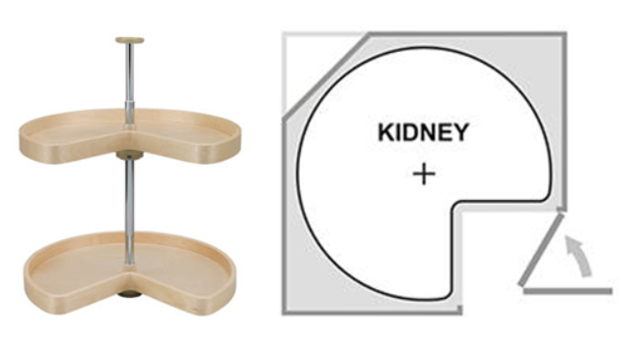

**Figure 2:** Kidney design Lazy Susan

Preceding design implementation, technical research and existing product analysis was executed in order to establish dog feeder product goals and specifications. Multiple dog-feeding apparatuses currently exist on the market. This includes elementary designs that simply gravity feed food into a bowl once the animal has eaten enough for there to be available room for more food to dispense. Most of these products provide food sealing to conserve freshness and can feed a medium-sized pet for up to 1 week.

Furthermore, there are also existing automated products for dog sustenance similar to the proposed design wherein user input dictates dispensed volumes and schedules. These types of devices are particularly useful in hands-off remote feeding. They also promote dog health ensuring proper sized meals. Additionally, many of the current apparatuses are user-friendly and provide portability. Another favorable feature provided in existing designs is the ability to control the dog feeder through smart phone apps. These types of systems are practical for single-dog homes.

The pet product company, Chewy, has various types of dog feeders currently on the market **[12]**. Some of their gravity fed options are displayed in figure 3. These products are less than adequate in keeping food fresh, and there is no control of serving amounts, leading to both undereating when food gets stale and overeating when unlimited amounts are available, which negatively affects dog health and lifespan. Furthermore, these types of products may present a danger in food aggression for multidog homes. It may also be more expensive for clients who are consistently overfeeding or having food spoil as they need to buy more dog food than required.

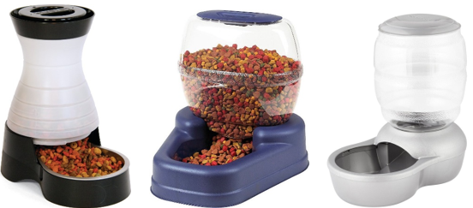

**Figure 3:** Multiple gravity fed dog food dispensers sold by Chewy.

Arf Pets manufactures and sells a more advanced pet-feeding apparatus, which provides a greater service for clients and their animals. This system, shown in Figure 4, implements a user interface for pet owners to feed their dogs the proper amount. Not only does it prevent overeating, but it also provides setup for up to four daily meals and customized portions. Setting adjustments are easily accessible through an LCD clock and display. It even has recording capabilities for tailored mealtime alerting. Furthermore, this apparatus has Bluetooth-capabilities, enabling for remote control **[13]**. ­

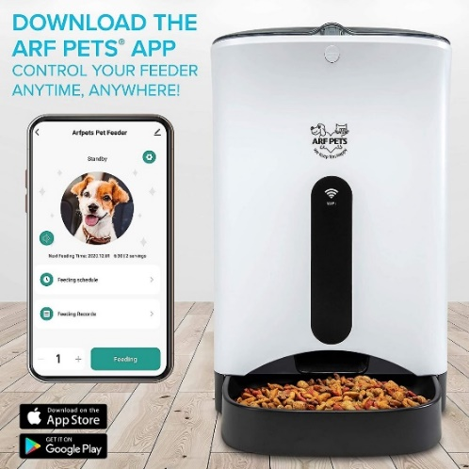

**Figure 4:** Arf Pets Automatic Smart Feeder Dog & Cat Food Dispenser.

It has been concluded that there are a wide range of dog feeding dispensers currently in the market, although some designs are more optimal than others. Gravity fed systems may be user-friendly and portable, but they do not prevent animals from overeating or stealing food. Existing automated feeders allow clients to control meal schedules and serving amounts remotely, which provides a valuable service for dog health. What hasn’t been done, is implementing the proficiencies of an automated system to provide multi-dog homes. The proposed design will provide all of the benefits of the currently available automated systems into a single unit that serves more than one animal. It will also include an alerting system, in a completely self-training aspect. Current products on the market fail to provide a user-friendly, multi-dog system, which promotes a safe environment coupled with hands-off remote feeding.

Concept Generation:

After performing a thorough technical research analysis, the design team underwent brainstorming sessions in order to generate various design concepts. In the beginning of these sessions, the quantity of ideas was emphasized, rather than the quality of the design. It was not until after building a large design portfolio, that refinement and improvements were made. In this way, the most proficient design ideas of each system were altered and combined. This is known as scamper brainstorming. The directed method of concept generation was utilized in a step-by-step technique to solve the problem. Technical research and information guided the design team through this process.

After the initial brainstorming session, forty-five-minute time-blocks were used to perform an intuitive method of concept generation. In these meetings, the existing ideas were broken down into several refined designs that could potentially work. Functionality was a key component in this step of the design. In doing so, individual ideas were expanded upon to generate more polished concepts.

One of the preliminary drafts, depicted below in Figure 5 **[15]**, proved to be a starting point for the finalized design. The layout of feeding compartments consisted of two drawers, one extending out the front of the apparatus, and one extending from the back. There are also two food storage chambers for housing differing types of kibbles. PVC pipes, extending down from each storage compartment, have augers inside them for food dispensing. These uniform augers were to be controlled by servo motors to transport the food in incremental periods into the bowls. The initial design for the bowl distribution was to have the bowls be nested within existing drawers and have them extrude out of the unit once the dog approaches. The drawers were to use a single rack and pinion shared between them, with only one side being able to be pushed out at once. This concept presented weaknesses in safety. Having drawers, presents a risk in them closing on the animals’ appendages. Additionally, utilization of augers results in the device being too tall. Since the food storage is located at the top of the dog feeder, having augers for dispensing, results in an overly top-heavy product.

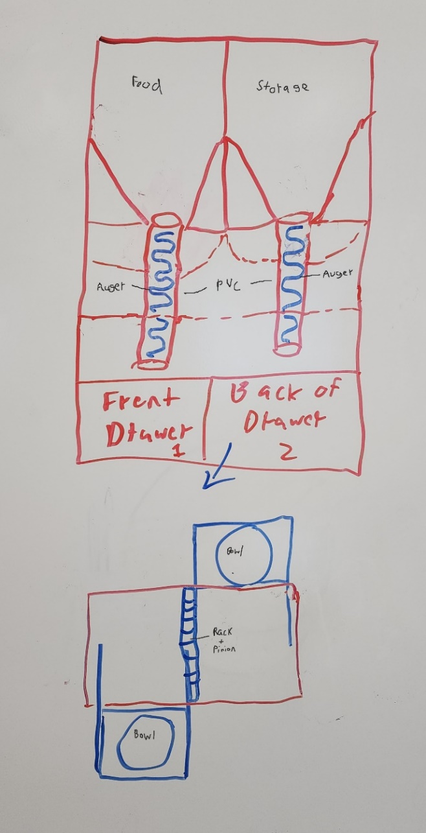

Uniform Auger

**Figure 5:** Sketch of first design draft. *Labeled in Adobe Photoshop*.

Another similar initial design included using paddle wheel dispensers. This is shown in Figure 6 **[16]**. The new dispenser design would have timers controlling the duration that the wheels would rotate, depending on the amount of food needed. The mechanical design of drawer operation is the same as Figure 5, but it was decided that weight sensors would be utilized under the bowls to aid in food consumption measurement. This was the first step in the self-training component of the dog feeder. Having weight sensors enables the refilling of only the top up amount of each serving. This teaches the animals to eat the entire bowl of food during feeding time and ensures freshness. It was determined that accuracy in food allocation may be a problem utilizing the paddle wheel concept, and they may jam or snag on the storage walls. The danger risk for dogs also still exists when using the drawers.

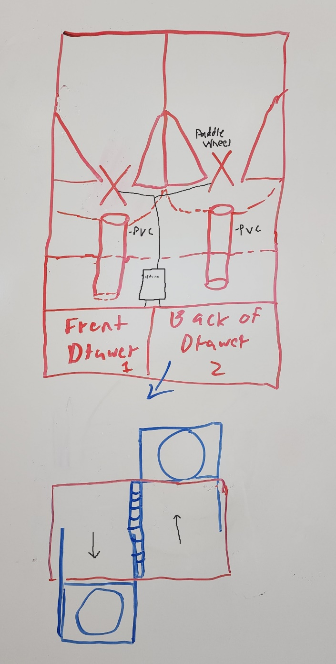

Paddle

Wheel

**Figure 6:** Sketch of second design draft. *Labeled in Adobe Photoshop*.

The third draft of the design saw the most substantial redesigns occur. The method of food dumping was, yet again, changed from a dual paddle wheel system to a custom-made design, that the team has titled the “Super Lazy Susan” (SLS). This dispenser serves to reduce space in the system and provide the torque necessary to still be able to move when the kibble on the higher end of the weight spectrum is used on the scale. The SLS will only dispense food in quarter cup quantities to improve accuracy and will act as a seal for the containers. Additionally, only one SLS is included to service both dog bowls. Unlike in previous designs, the bowl drawers are directly opposite one another, coming out on opposite sides of the device. The shared rack and pinion system is ditched in favor of separately controlled drawers for ease in feeding multiple dogs. In order to prevent animals from breaking into the feeder, there will be a roof that protrudes out of the sides of the apparatus. This structure will leave just enough room for the bowl to fit under it. Once the bowl is extended past the roof, the food will be available for the dog. After feeding, the bowl will be retracted back into the main housing compartment, and a door will shut behind it for an extra level of security. The sensing ability of the drawer doors was to be dictated by a Radio Frequency Identification RFID sensor with tags that could be fitted onto a dog’s collar. This concept is featured in Figure 7. This design solves many of the drawbacks of the previous ones, although further investigation is required to improve the safety of the drawers.

**Figure 7:** Sketch of third design draft. *Labeled in Adobe Photoshop*.

The fourth draft focuses on the redesign of the bowl carry system and is shown in Figure 8 **[17] [18]**. The doors on the feeder were replaced with a vinyl covering. The drawers were eliminated to improve safety. Rails are to extend the proper bowl through the vinyl on the RFID connection. The platforms holding the bowls have been replaced with a custom tomahawk-shaped platform. Resting on the larger width area of the platform is a secondary support for the bowl and weight measuring device. On the thinner portion of the structure, the racks and pinions will be held. In this design, dogs may be able to break into the device through the vinyl coverings. Further brainstorming was needed in order to resolve this issue.

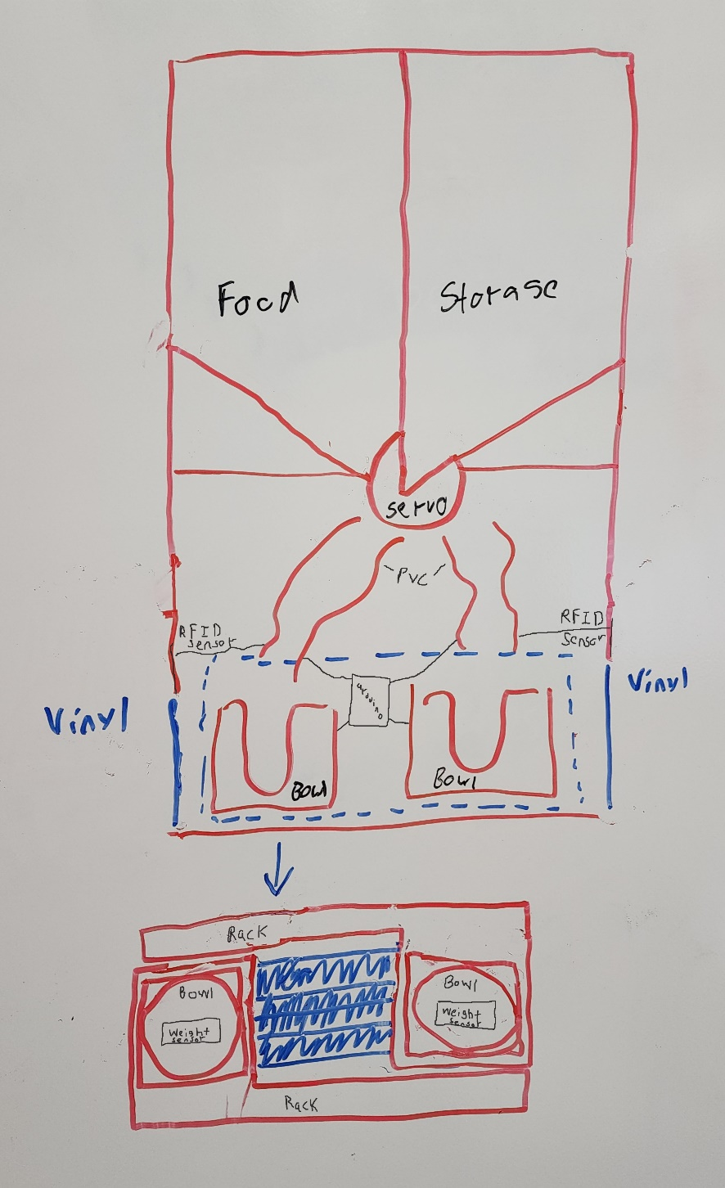

Perforated

Vinyl

**Figure 8:** Sketch of fourth design draft. *Labeled in Adobe Photoshop*.

All brainstormed designs share some commonalities, such as separate compartments for multiple types of food to be used at once, a food safe PVC pipe for food delivery, moving bowls housed in frames, a method of dog detection, and some sort of incremental food delivery system. A strength and weakness analysis was performed to determine which design components were to be utilized in the proposed design. Each component was rated through an analytical process in order to refine and combine the most appropriate concepts into the proposed design. This was done to define the system process that most evidently satisfies the technical engineering needs. In order to perform Pugh analysis, the design in figure 8 was chosen as a baseline concept. Each design was compared to the baseline with positive, negative, or neutral analytical scores. From this process, a Pugh Concept Table, shown in Table 4, was implemented based on the following criteria:

1. Functionality.
2. Utilization of space.
3. Cost.
4. Safety.
5. Efficiency.
6. Accuracy.

**Table 4:** Pugh Concept Table showing comparison to baseline design (+1 = better than, 0 = equal to, -1 = worse than).

|  |  |  |  |  |
| --- | --- | --- | --- | --- |
| **Criteria** | **Benchmark Design**  (Figure 8) | **Design 1**  (Figure 5) | **Design 2**  (Figure 6) | **Design 3**  (Figure 7) |
| **1** | - | 0 | 0 | +1 |
| **2** | - | -1 | -1 | 0 |
| **3** | - | -1 | -1 | 0 |
| **4** | - | -1 | -1 | -1 |
| **5** | - | -1 | -1 | 0 |
| **6** | - | 0 | -1 | 0 |
| **Score** | - | -4 | -4 | 0 |
| **Continue?** | Combine | No | No | Yes |

From the Pugh analytical analysis, it was determined that certain design aspects from concept 3 (Figure 7), would be combined with the benchmark concept (Figure 8). After performing this exploration, a more complete design was decided upon in order to meet the specified criteria. A sketch of this collaborative design is featured in Figure 9. The top of the apparatus consists of two food storage compartments. The SLS will service both compartments and will be controlled by a servo motor. The SLS will dispense food amounts in quarter cup increments into the heat molded PVC conduits. The PVC acts as a funnel for the food to fall into the proper bowl. Each bowl will sit on a platform, which will be fastened to two extendable tracks. A motorized wheel is to be used to extend and retract each platform for feeding. The tracks will push the bowl through a vinyl curtain that will act as a barrier between the dog and dispensing chamber. Additionally, a roof will protrude from the sides of the feeder, leaving just enough space for the bowl to fit under it. The bowl will extend past this roof during mealtime. Having this small space under the roof will prevent animals from breaking into the dispensing compartment and eliminate any pinch points. RFID sensors will be utilized for dog sensing and to initiate track extension. Lastly, weight sensors will detect how much food remains in the bowls.

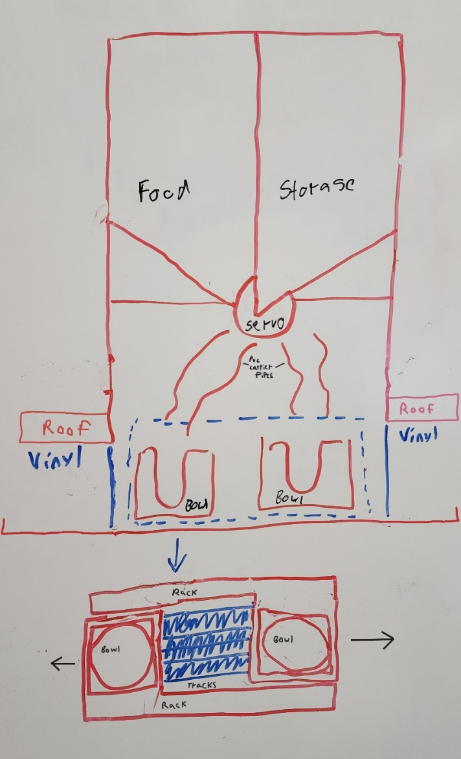

**Figure 9:** Sketch of proposed design. *Labeled in Photoshop*.

**Design Description:**

Physical Design:

Once a more complete design was sketched and decided upon, a higher quality, and more realistic representation was constructed using Solid Works Software. Individual components were modeled before assembling them into one unit. The physical image of the feeder below, in Figure 10, is a complete assembly of the system components. The top portion of this design consists of two storage compartments for housing dog food and the SLS for food distribution. Additionally, the LCD screen, buttons, and Arduino controller are located in this section. The mid-section includes two funnels connected to PVC conduits for food allocation. Lastly, the lower portion of the feeder holds the bowls. Each bowl sits in a housing unit that contains weight sensors and is attached to a platform. The platforms are fastened to two sliding rails that are controlled by a Direct Current (DC) powered wheel.

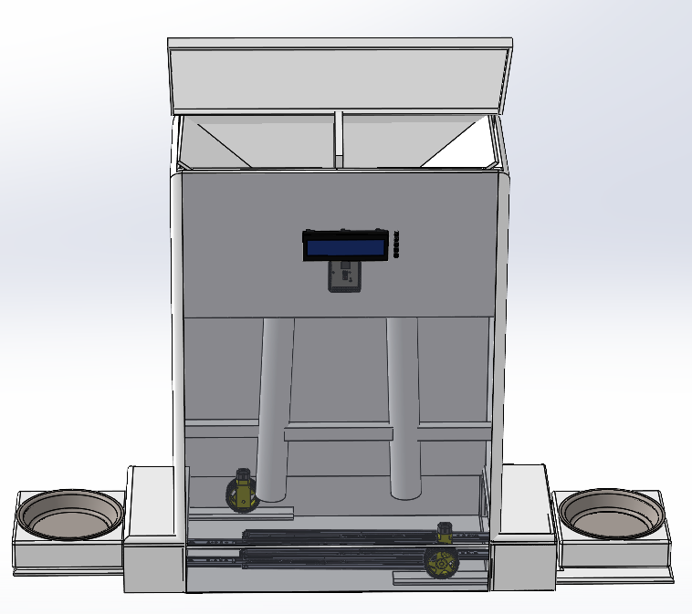

**Figure 10:** Proposed physical design. *Created in Solid Works Software.*

Figure 11 shows the skeleton of the feeder frame, as well as the angled ramps for the feeding compartments. The angled ramps, which make up the food hopper compartments, will be fastened inside the top portion of the frame. Calculations for overall feeder dimensions and food compartment volumes need to be performed. Additionally, experiments will be performed in order to determine the ideal degree of angle for the ramps.

Hopper

Feeder Frame

**Figure 11:** Feeder frame and hopper. *Created in Solid Works Software.*

The SLS will be located below the food compartments and will service both bowls. It will be controlled by a servo motor with 270° rotation capabilities. This will allow the SLS to dispense food from either food section. Directly below and slightly to each side of the SLS, two funnels will be used to direct the food into the proper bowl during dispensing. These components are featured in Figure 12 **[19] [20]**.

Funnel

Servo Motor

“Super Lazy Susan”

**Figure 12:** Servo motor, SLS, and funnels. *Created in Solid Works Software.*

Located under the funnels will be a bowl for each dog. The bowls will sit in a fitted holder, ensuring their security. Within the base of the holder, a weight sensor will be embedded in order to track food amounts. This ensures that each dog has eaten the proper amount of food. These components are shown in Figure 13 **[21]**.

Bowl Holder

Weight Sensor

Bowl

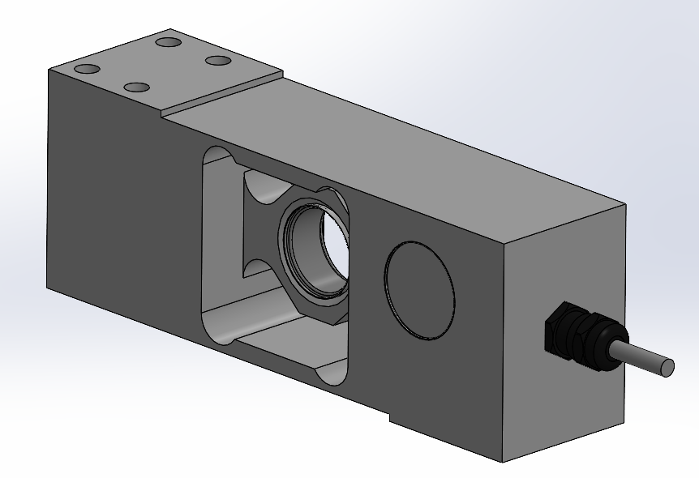

**Figure 13:** Bowl, bowl holder, and weight sensor. *Created in Solid Works Software.*

The devices, presented in Figure 14 **[22] [23]**, are housed beneath the bowl holder. Four extendable tracks will be mounted to the base of the feeder frame. A platform, for each bowl holder, will be fastened to two of the rails. Both platforms have a narrow protrusion that is used as a track for the DC motor operated wheel. The wheel will be mounted to the base of the feeder frame and fitted to the protrusion. The stationary wheel will use the track to extend and retract its designated bowl and platform unit. The use of a rubber wheel is for expedient and inexpensive prototyping; an ideal solution is the use of a rack and pinion, with the rack being machined into the platform extension.

Motor

Wheel

Platform

Telescoping rail

**Figure 14:** Platforms, telescoping rails, motor, and wheels. *Created in Solid Works Software.*

An Arduino Mega, a microcontroller development board, will be programmed in order to operate all system components. This includes energizing and de-energizing the servo motor for SLS rotation and functioning the DC motors for platform extension and retraction. Additionally, it will receive input signals from the RFID tags and weight sensors for proper feeding amounts and times. A user-interface LCD screen and buttons will allow pet owners to select feeding schedules and amounts. These images can be seen in Figure 15 **[24] [25] [26]**.

Buttons

LCD

Arduino Mega

**Figure 15:** Arduino Mega microcontroller and LCD/Button Interface. *Created in Solid Works Software.*

Figure 16 consists of two images of the completely assembled dog feeder. As shown, one figure shows the left bowl extended for feeding, and the other shows the right bowl extended for feeding. In this way, each dog will have different feeding times.

**Figure 16:** Dog feeder with components assembled, showing left bowl extended, and right bowl extended. *Created in Solid Works Software.*

Functional Decomposition:

The level 0 functionality process flow diagram is shown in Figure 17 below, which showcases the dog feeder as the main module. The design requires a 120 Alternating Current (AC) voltage power source, operating from a 15-amp circuit. User input dictates the feeding amount for each dog. The level 1 modules are housed within the level 0 dog feeder module.

**Figure 17:** Flow diagram for dog feeder level 0 functionality including imbedded level 1 modules. *Created with Lucidchart.*

Table 5 consists of a breakdown of the level 0 decompositions. This includes the inputs of the power source and user input for feeding amounts and schedule. The output includes the dispensing and availability of food for the animal. The functionality description explains how the inputs are utilized to achieve the desired output.

**Table 5:** Level 0 Dog Feeder Functionality.

|  |  |
| --- | --- |
| Module | Dog Feeder |
| Inputs | * Users Feeding Desires * Power: 120 volts AC rms, 60Hz |
| Outputs | * Dog is Fed |
| Functionality | Dog is fed according to users input settings. System should be able to feed a large dog for a week, contained within the design is space for 2 gallons of kibble. |

The level 1 functionality process flow diagram for the power system is shown below in Figure 18. This system receives the 120 AC voltage input and transforms and rectifies it into the appropriate direct current outputs. The level 2 modules within the power system include the charging circuit, DC battery, and conversion process. The power system outputs 5 volts DC and 12 volts DC.

**Figure 18:**  Flow diagram for dog feeder level 1 power system functionality including imbedded level 2 modules. *Created with Lucidchart.*

Table 6 consists of a breakdown of the level 1 power system decompositions. This includes the input of the power source and the DC outputs. The functionality of the power input and output processes is explained.

**Table 6:** Level 1 Power System Functionality.

|  |  |
| --- | --- |
| Module | Power System |
| Inputs | * Power: 120 AC rms, 60HZ |
| Outputs | * +5 Volt DC. |
| Functionality | Rectify 120 AC into +13.8 Volts which is supplied into a 12-volt battery. This battery is stepped down to 5 volts for use throughout the system. |

The level 1 functionality process of food measurement and dispensing are shown below in Figure 19. The system inputs consist of food and user setup. The level 2 modules within the measurement and dispensing module include the sealed hopper, control, food measurement and dispensation, detection of food, and feeding container. The output is the appropriate measured food quantity.

**Figure 19:** Level 1 Measurement and Food Dispensing functionality and Level 2 details. *Created with Lucidchart.*

Table 7 consists of a breakdown of the level 1 measurement and food dispensing functionality. This includes the inputs of dog food and user setup execution. The functionality of the input and output processes is explained.

**Table 7:** Level 1 Measurement and Food Dispensing functionality.

|  |  |
| --- | --- |
| Module | Measure + Dispense Food |
| Inputs | * Dog food. * User setup input. |
| Outputs | * Measure food amount |
| Functionality | Measures food in bowl currently and based on user’s setup options dispenses set food amounts from storage containers to bowl. |

The level 1 functionality for dog detection and food supply is shown below in Figure 20. The system inputs consist of user settings. The level 2 modules within the detect and supply module include control, call dog, detect dog, and feeding device. The output is making the food available for eating.

**Figure 20:** Level 1 Dog Detection + Food Supply functionality and Level 2 details. *Created with Lucidchart.*

Table 8 shows a breakdown of the level 1 detect and supply functionality. This includes the inputs of user settings and food measured. The functionality of the input and output processes is explained.

**Table 8:** Level 1 Dog Detection + Food Supply functionality.

|  |  |
| --- | --- |
| Module | Detect + Supply Food |
| Inputs | * User settings. * Food measured. |
| Outputs | * Dog is supplied food. * Call upon dog. |
| Functionality | System will supply set amount of food, then will call the dog when it is time to eat. It will also detect when the correct dog arrives at the system and extend the correct bowl. |

The level 1 functionality for user programming is featured below in Figure 21. The system input consists of user-desired settings. The level 2 modules within the user programming module include user input, control, user output, and system. The output is the user-selected settings.

**Figure 21:** Level 1 User Programmability functionality and Level 2 details. *Created with Lucidchart.*

Table 9 shows a breakdown of the level 1 programmability functionality. This includes the input of desired user settings and the output of user-selected settings. The functionality of the input and output processes is explained.

**Table 9:** Level 1 Programmability Functionality.

|  |  |
| --- | --- |
| Module | User Programming |
| Inputs | * User desired settings |
| Outputs | * User selected settings |
| Functionality | User should be able to select the amount and frequency in which their pet is fed. The system should be easily usable by the owner. |

Electrical Design Elements:

The central electrical board will be an Arduino Mega development board which houses the ATmega2560 microcontroller and associated support circuitry as well as an LM1117 linear voltage regulator that supplies 5 volts to the microcontroller and logic circuits. Power will be supplied by a 12-volt battery that is constantly charged from mains power using a voltage limited charger below. The servo motor operating the SLS, the LCD screen, the weight sensors, and all switches and buttons, will be powered by the Arduino board. Due to both a greater current draw and a requirement to operate in two directions, the DC motors on the pinion of the bowl platform, rack and pinion will be powered through a separate motor driver circuit. The Secure Digital (SD) card module, Real-Time Clock (RTC), RFID antenna, and Inter-Integrated Circuit (I2C) LCD driver will be commercially available boards, as noted in the cost analysis. The final electrical design will integrate all components into a single power and control board.

Below, in Figure 22, is the circuit for constant charging of the backup battery; a transformer and full bridge rectifier provide a DC power source, and a Darlington transistor with its base clamped at 15 volts by a Zener diode provides a charging current at a maximum of 14.3 volts, which will be ideal for a lead acid battery as it is the maximum voltage that will not cause gasification [14]. For purposes of expedient prototyping, this circuit will be substituted for a commercial battery trickle charger in the prototype.

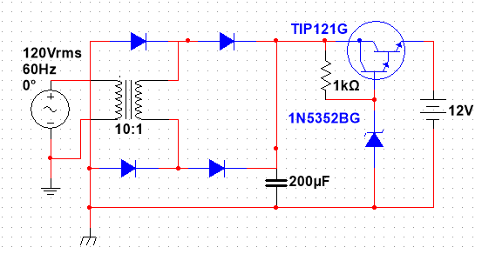

**Figure 22:** Diagram of battery charging circuit. *Created in NI Multisim.*

The Motor control driver circuit uses a basic H-bridge to achieve two-directional control of the pinion drive DC motor to operate the food bowl platforms using two digital output lines of the microcontroller. This is featured in Figure 23. One driver will be included for each pinion motor, for a total of two. Metal-Oxide-Semiconductor Field-Effect Transistors (MOSFETs) are used for their high current capacity so that the circuit is resilient to the high currents drawn during motor stall after opening the platform, and for the internal diode, which will work as flyback diodes on motor shutdown. The “Forward” and “Reverse” connections will be operated by Pulse Width Modulation (PWM) capable lines on the Arduino board so that motor speed can be modulated.

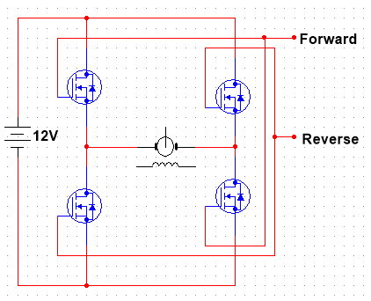

**Figure 23:** Diagram of motor direction controller. *Created in NI Multisim.*

Software Design Elements:

The software design consists of three modules: a central loop that runs continuously and two routines that are called when needed.

The central loop in figure 24 runs continuously, beginning with a processor sleep time used to minimize power consumption. The loop then queries the RIFD module for the presence of either dog’s RFID tag and responds to the presence of a dog by extending the feed platform if the correct dog is present and closing the other dog’s feeding bowl. If no dog is present, during feeding times, both platforms will be closed to preserve the freshness of the remaining food. Boolean values will be used to hold the position of the bowl platforms so that an attempt to close or open a platform that is already in the desired position is not commanded. After checking for dogs, the process then reads the time from the real time clock into memory and updates the LCD display. The current time is then compared to the scheduled feeding times, and if one is within the duration of the feeding cycle, then the feeding cycle is called.

**Figure 24:** Central Loop Flowchart. *Created with Lucidchart.*

The user interface in Figure 25 contains a menu for the user to set desired options. The user will interact with the system through the use of 5 buttons: Menu, Back, Up, Down, and Enter. Pressing the Menu button at any time will call the menu by action of an interrupt and Interrupt Service Routine (ISR). The user will be presented with 4 options: Time Set, Dog 1, Dog 2, and Option. The Up and Down arrows will navigate through the menu, and the Enter button will be used to select. Selection of Time Set will launch an interface to set the date and time, which will be updated in the real-time clock module when complete. Both dog selections will branch to a menu with two feeding times, morning and evening, which both branch to a menu to set the time and amount of food to be fed, including the options to react to food remaining in the bowl during the feeding cycle.

**Figure 25:** User Interface Flowchart. *Created with Lucidchart.*

The feeding cycle, featured in Figure 26, handles the measurement and dispensing of food and calling dogs at feeding time. When a feeding cycle is begun, the bowl is weighed to determine the amount of food remaining and the amount of food to be dispensed. If the bowl is determined to be full, the feeding amount is set to zero so that the bowl is not overfilled, resulting in food spilling inside the feeder. The cycle then queries the user’s settings for feeding quantity and procedure. In the case of a user’s selection to always feed the selected amount, the dispensed amount is set to the minimum of that amount or the amount of space remaining before the bowl is full. In the case of user selection to fill the bowl to the dog’s serving amount, the feeding amount is set to the difference of that amount and the remaining food. In the case of the user’s selection to wait until the bowl is empty to refill, the presence of remaining food is determined within the range of accuracy of the weight sensor, and the feeding amount is set to none if food remains and to the selected quantity if the bowl is determined empty. Once the feeding amount is determined and rounded to the nearest dispensable amount, this amount is dispensed into the bowl by the SLS, and the selected call played to alert the dog to available food. After the completion of the feeding cycle control is returned to the central loop, which handles opening the feeding bowl platform when the dog arrives.

**Figure 26:** Feeding Cycle Flowchart. *Created with Lucidchart.*

**Iterative Nature of Design Changes:**

The preliminary design of the bowl extension construction and location was altered numerous times. There were many options for how the food would be presented to the animal, such as differing drawer and door types for opening and closing. After an analysis of safety improvements was performed, a change was made from an actual draw or closing mechanism to a vinyl curtain and overhanging roof. This was done in order to make the feeder safer by eliminating pinch points. In doing so, the amount of hardware and moving parts implemented in the system was minimized, improving efficiency and cost. The location of the extension of the bowls was also altered several times and is shown in concept generation. These changes were brought about to reduce the amount of space required for the feeder. The final location of bowl extrusion was ultimately decided to have each bowl extend out on opposite sides of the feeder, running parallel with the wall or structure that it is up against. In this way, the product becomes more user friendly and economical in terms of space consumption.

Another major feature that required major design alterations was in the food dispensing components. The original design consisted of using two augers, one for each dog bowl, to facilitate both food compartments. The use of two augers would not be economical in space. Additionally, it increased the cost of the product. As a result, paddle wheels were selected to dispense kibble from each food chamber. This helped minimize the size of the product. The rotation of the paddle wheels was to be set on timers. Unfortunately, it was discovered that the accuracy of food volumes may be an issue. In order to find a solution, the design team decided to produce its own dispensing device. It was ultimately decided that a single SLS would be used to service both bowls. This improved affordability, decreased the height of the feeder, and improved the accuracy of feeding amounts.

The food hoppers were originally envisioned as separate, sealed containers contained within the structure of the automated feeder frame. Taking inspiration from airplane wing fuel tanks, the design was changed so that the hopper was made of the outer structure of the feeder, reducing complexity, material usage, and cost while increasing the possible volume of the containers.

The battery charging circuit was originally envisioned as only a full-bridge rectifier with a transformer designed to reach peak voltages just below the gasification voltage of lead acid batteries, this design was abandoned as short circuits could occur during AC power loss. The current design does not short out during AC power loss and automatically shuts down when the battery is fully charged. Continuing iterative design would add microcontroller control of the charging circuit and monitoring of the battery. The DC motor controllers were initially expected to be made using Bipolar Junction Transistors (BJTs) however during testing of the DC motors, they were found to pull currents greater than 1A during stall immediately before shutdown, which would require high current capable transistors and flyback diodes. Both problems were solved by changing to MOSFETs. Calling the user interface and monitoring button presses were initially considered to be part of the main loop of the software; while building flowcharts, the idea of compartmentalizing the user interface was pitched, and the idea of using an ISR came up in the resulting discussion. Upon verification that interrupts were supported by the microprocessor, it was decided to do so.

**Cost Analysis:**

Materials for the prototype were chosen with a priority on availability, timely delivery, and capability. As such, the prototype materials are intentionally overspecified and chosen from suppliers with higher prices but smaller quantities and faster shipping. Shown below, in Table 10, is the expected Bill of Materials (BOM) to complete a functional prototype.

**Table 10:** Bill of Materials.



The total BOM is well below allowable cost, however far above intended design marginal production cost. Materials and suppliers will be revisited upon completion of a functioning prototype to determine the most cost-effective parts and sources for a production model.

**Ethics and standards:**

Ethics:

This device should not be used as a direct alternative to human interaction with feeding and training. It should be used as a supplementary tool to aid in training and to assist the owner when they are otherwise preoccupied. The device should not harm the dog in any way, from the tray not pinching the dog to the calling sounds not damaging their ears. The dog feeder allows pet owners to feed dogs remotely for a minimum of one week, although it is not promoted or recommended to leave pets unattended for this period of time. Its convenience in allowing remote feeding is not a supplement for taking care of dogs.

Standards:

Product standards are one of the most rigorous and important standards to follow when creating a consumer product. Not following these standards can compromise the safety and consistency of your product. An important standard, the Due Care practice standard, is followed to ensure the legitimacy of their product at every step of the supply chain. Products should not be created with unlawfully sourced material. Through the Code of Federal Regulations (CFR) there are several regulations surrounding consumer products with electronic components that must be adhered to. For the use of an RFID detector, 47 CFR part 15 must be followed. Which consists of several standards that all pertain to the regulation of radio frequency energy emissions in the 9khz to 3000 GHz range. Depending on the retailer selected, a product may be subject to Underwriter Laboratories (UL) standards. These include standards for isolating signals and feedback, safety requirements for electronics, and standards for insulation systems. Products that are authorized under 47 CFR Part 15 must contain the product’s name, model number, The name, address, contact information of a US-based responsible party, and a statement that the product complies with 46 CFR Part 15. For bulk parts ordered, importer and manufacturers of certain types of electronic products in the United States must issue aSupplier’s Declaration of Conformity (SDoC). SDoC requires the party responsible for compliance to ensure that the equipment complies with the appropriate technical standards. 21 CFR 175 requires that adhesives or other coatings within the product meet FDA food safety standards. For most consumer products imported or manufactured in the United States country of origin labeling is required.

**Hazards and Failure Analysis:**

A major concept consideration of the proposed design included providing a safe environment for both humans and pets. In fact, one of the main problems being solved by this product is food aggression in dogs. The dog feeder was designed in such a way to remove people from the feeding environment completely. Allowing individuals to feed their pets remotely, for a minimum of one week, minimizes the danger to humans during feeding times. It was also paramount to style the product in such a way to keep dogs safe from potential food aggression episodes at feeding times. This was done with the use of RFID detection sensors located on the animals’ collars. In this way, altercations between the dogs over food are reduced because the proper food compartment will only open if the correct dog is within 1 meter of the apparatus during its scheduled feeding time. If the incorrect dog is within 2 meters of the feeder, the compartment will not open. Additionally, if the compartment is already open, it will also close if the wrong animal is sensed within the 2-meter range. At these distances, it is impossible for both animals to be eating out of the same food bowl at the same time. This keeps the dogs in a certain proximity to each other when food is available, which helps eliminate any confrontations. It is also meant for the dogs to eat at different times, further protecting the animals from dangerous situations.

It is also essential that the food be kept fresh and uncontaminated in its housing compartments. The storage compartments were chosen with the use of sealable, food-safe material that will not cause any chemical changes to the food itself. This eliminates any potential toxic or dangerous contamination to the dog kibble. Furthermore, since the bowls will be extending and retracting in and out of the sides of the feeder, it was important to remove any potential pinching hazards for the animal. This was done by removing any drawers or doors from the design that open and close in such a way that could result in animal appendages being caught or pinched in them during operation. To do this, vinyl flaps are used on the sides of the feeder. The bowls extend through these vinyl flaps. Once past the flaps, a roofed-housing unit will cover the bowl, leaving just enough space for it to extend out of the feeder. The food will protrude past this housing unit and be available for feeding at that time. Since there is no room for an animal’s limbs to fit under the extended roof, pinch points were eradicated during the design process.

Maintaining safety for users and the environment was also considered further. To do so, operating voltages were kept low to reduce any chance of electrical shock or the production of high levels of electromagnetic waves. The system is powered using a 120-volt, 15-amp alternating current outlet. This is the most common power source used in households in North America, making it the most convenient and safe option. This voltage is then transformed into 12 DC voltage for charging, making it even safer for users and the environment. Furthermore, a voltage regulator on the Arduino controller drops the 12 volts to 5 volts for component and system operation. Having all electrical components placed in a secure compartment away from the user and operating at low voltages and currents rids the system of any potential electrical shock hazards.

**Management of the project:**

Each team member is responsible for specific design elements and implementation of the automated dog feeder. The delegation of individual responsibilities is based on each team member's skillset and expertise. Brian Grahmann fills the role of “Software Expert”. This includes the controller selection, integration, and implementation of coding and configuration. Slaton Bird is responsible for all system flow diagrams and explanations. His skills are utilized in software, such as Solid Works and Lucidchart to produce accurate explanations and representations of the proposed design. He also collaborates with Brian in software and codes design. Kelby Lang is the team leader, tasked with communicating and coordinating team meetings. A major duty of his is in report writing and refinement. Kelby is also responsible for the mechanical design of the product, as well as the prototype construction process. Lastly, he communicates with upper management pertaining to any concerns that need to be addressed and finds solutions for meeting technical and customer needs. A further breakdown of team member responsibilities is shown in Table 11.

**Table 11:** List of team member responsibilities.

|  |  |
| --- | --- |
| **Team Members** | **Responsibilities** |
| Kelby Lang | * Project management. * Communication with upper management. * Delegating tasks. * Coordinating group meetings. * Technical report writing and formatting. * Mechanical design. * Prototype construction. * Confirms technical and customer needs are being met. * Testing plan. * Implementation of testing. |
| Brian Grahmann | * Software selection. * Software integration. * Software implementation. * Coding and configuring. * Technical report writing and formatting. * Testing plan. * Implementation of testing. |
| Slaton Bird | * System flow diagrams and explanations. * Virtual representation of proposed product. * Design changes. * Physical design software. * Software and coding design. * Technical report writing and formatting. * Testing plan. * Implementation of testing. |

**Prototyping:**

Prototyping will be executed in phases over a span of approximately 2 months, allowing for design changes, alterations, improvements, and refinements. This ensures that the product will function efficiently and safely. The prototyping schedule is based on team member availability and skillset. The beginning stages will consist of building the physical frame out of wood. Following that, the food compartments will be constructed, as well as the SLS. The bowl railings are then mounted to the base of the feeder with the platforms and bowl holders. The second stage consists of mounting all electrical components, such as motors and sensors. System wiring and programming will be implemented in this stage. The final stage consists of testing and alterations. In this stage, system processes will be confirmed and refined. Table 12 includes a breakdown of the prototyping timeline, responsibilities, and tasks. It was ensured that the timeline allowed for system testing and changes that could possibly cause delays. Kelby Lang was responsible for physical construction, layout, and circuitry. Brian Grahmann and Slaton bird were responsible for programming, coding, and implementation of the transforming circuit. System testing and refinement are to be done collectively.

**Table 12:** Prototyping Schedule

|  |  |  |
| --- | --- | --- |
| **Schedule** | **Responsibility** | **Task** |
| Feb 18-19 | Kelby Lang | * Frame built. * Rails mounted. * Bowl platforms cut and mounted. * First version of Super Lazy Susan (SLS) construction. |
| March 11-12 | Slaton Bird  Brian Grahmann  Kelby Lang | * Bowl holders constructed. * Weight sensors mounted. * Bowl holder mounted to platform. * Side wall cutouts for bowl extension. * Transforming circuit constructed. * Initial coding started. |
| March 13-19 | Slaton Bird  Brian Grahmann  Kelby Lang | * SLS improved and reconstructed. * Mounting SLS and servo motor. * Location picked for Arduino. * Additions to programming and coding. * Side roofs constructed and attached to frame. * Food compartments constructed and installed. * DC rail motors and RFID sensors installed. * Instillation of step-down circuit. |
| March 25-29 | Slaton Bird  Brian Grahmann  Kelby Lang | * Funnels installed. * Physical component operation testing. * Program download. * Software input & output testing. * Implemented necessary changes. |
| March 31-April 2 | Slaton Bird  Brian Grahmann  Kelby Lang | * Testing continued. * Step-by-step operation. * Scenario change testing. * Making alterations and improvements. |
| April 14-16 | Slaton Bird  Brian Grahmann  Kelby Lang | * Finish simulations and alterations. * Prototype finished and operable. |

**Testing Verification:**

Eight formal tests of the prototype are scheduled and are shown in Figure 27. The Mechanical, Motor Software, User Interface, and Software Settings unit tests individually verify the function of component parts of the total system after development. After preliminary testing, the motor software is further developed to interface with all sensors. All of the components are then tested in two steps as they are integrated into the main mechanical and software sections before performing an all up Operational Test of the final prototype.

**Figure 27:** Testing and Integration Plan. *Created with Lucidchart.*

The Mechanical Unit Test (Figure 28 below) is performed upon completing construction of the primary housing and mechanical portions of the feeding platforms and SLS. This test ensures that the feeding platforms and SLS function as intended and are capable of supporting the forces involved while moving smoothly enough to be operated by microcontroller-controlled motors. The procedure also includes a measurement of the torque required to turn the SLS so that the requirements of the production servo motor can be assessed.



**Figure 28:** Mechanical Unit Test. *Created with Microsoft Excel.*

The Software Motor unit test shown (Figure 29 below) is performed upon completion of the DC motor driver circuits and code for both the DC motors and servo motor. This test verifies that the software and driver circuits are capable of operating the DC motors in both directions and positioning the servo motor as needed to actuate the SLS.



**Figure 29:** Software Motor Unit Test. *Created with Microsoft Excel.*

The Motor Actuation Integration test (Figure 30) is performed after the DC motors and servo motor are attached to the mechanical portion of the prototype. This test verifies that the motors, driver circuits, and software can smoothly operate the SLS and feeding platforms. The results of this test will determine if modifications must be made to run the motors with PWM or at a higher supply voltage.



**Figure 30:** Motor Actuation Integration Test. *Created with Microsoft Excel.*

The Software Sensors Unit test (Figure 31) is performed upon completion of the software to read the weight sensors, RFID, and feeding platform position microswitches. This test verifies the functionality of all sensors and related software before integrating them into the prototype.



**Figure 31:** Software Sensors Unit Test. *Created with Microsoft Excel.*

The User Interface Unit Test (Figure 32) tests the user interface buttons and LCD for menu navigation and the ability to call the functions to set time and feeding schedules. Placeholder functions are used to make serial output calls to verify that the selected functions are being called.



**Figure 32:** User Interface Unit Test. *Created with Microsoft Excel.*

The Software Settings Unit Test (Figure 33) verifies that the functions, to be called by the user interface, can properly set the time on the RTC, and write the feeding schedule to the Electronically Erasable Programmable Read-Only Memory (EEPROM). This test also verifies that the user selected feeding settings and current time are retained in EEPROM and the RTC during loss of power events and that the software can recover and resume operation.



**Figure 33:** Software Settings Unit Test. *Created with Microsoft Excel.*

The Functional Menu Integration (Test Figure 34) is performed after the User Interface (UI) and software settings have been combined into the full scheduling and control portion of the software. This test verifies that the user interface interacts with the software settings as intended and that the user is capable of controlling all device functions through only the use of the five supplied buttons and feedback from the LCD.



**Figure 34:** Functional Menu Integration Test. *Created with Microsoft Excel.*

The Operational Integration Test, Figure 35, is the first all-up test of the prototype. This test is performed after all other units have been built, tested, and integrated into version 1.0 of the prototype. This test verifies the function of the full prototype and will identify any need for modification in the final design.



**Figure 35:** Operational Integration Test. *Created with Microsoft Excel.*

**References:**

1. “Obesity in dogs: VCA Animal Hospital,” *Vca*. [Online]. Available: <https://vcahospitals.com/know-your-pet/obesity-in-dogs>. [Accessed: 25-Jan-2023].
2. [Online]. Available: <https://rawbistro.com/blogs/raw-bistro/food-aggression-in-dogs#:~:text=Try%20these%20seven%20steps%20to%20help%20put%20a,eat%20food%20from%20a%20bowl%20on%20the%20floor>. [Accessed: 25-Jan-2023].
3. “Pet ownership statistics [2022]: U.S pet population,” *Spots.com*, 07-Dec-2022. [Online]. Available: <https://spots.com/pet-ownership-statistics/>. [Accessed: 25-Jan-2023].
4. R. M. Ford and C. S. Coulston, “Chapter 3.5: Advanced Requirements Analysis,” in *Design for electrical and computer engineers: Theory, concepts, and Practice*, Boston, MA: McGraw-Hill, 2008, pp. 57–58.
5. R. M. Ford and C. S. Coulston, “Chapter 3.5: Advanced Requirements Analysis,” in *Design for electrical and computer engineers: Theory, concepts, and Practice*, Boston, MA: McGraw-Hill, 2008, pp. 58–59.
6. R. M. Ford and C. S. Coulston, “Chapter 3.5: Advanced Requirements Analysis,” in *Design for electrical and computer engineers: Theory, concepts, and Practice*, Boston, MA: McGraw-Hill, 2008, pp. 60–61.
7. *Rotary livestock feeder with gravity flow feed openings*. (n.d.). Retrieved February 17, 2023, from https://www.mysciencework.com/patent/show/rotary-livestock-feeder-gravity-flow-feed-openings-US20150359191A1
8. Google. (n.d.). *US5363805A - Automatic Pet Feeder*. Google Patents. Retrieved February 17, 2023, from https://patents.google.com/patent/US5363805A/en
9. Google. (n.d.). *US4181037A - lazy Susan Assembly having an adjustable alignment mechanism*. Google Patents. Retrieved February 17, 2023, from https://patents.google.com/patent/US4181037
10. R. M. Ford and C. S. Coulston, “Chapter 3.5: Advanced Requirements Analysis,” in *Design for electrical and computer engineers: Theory, concepts, and Practice*, Boston, MA: McGraw-Hill, 2008, pp. 57–58.
11. G. Reviews, “What is the difference between kidney-shaped and Pie Cut lazy susans?,” *Woodworker Express*. [Online]. Available: https://www.woodworkerexpress.com/kidney-shaped-vs-pie-cut-lazy-susans/. [Accessed: 04-Mar-2023].
12. “Arf Pets Automatic Dog & Cat Feeder, white, 18-Cup,” *ARF PETS Automatic Dog & Cat Feeder, White, 18-cup - Chewy.com*. [Online].
13. “Arf Pets Automatic Dog & Cat Feeder, white, 18-Cup,” *ARF PETS Automatic Dog & Cat Feeder, White, 18-cup - Chewy.com*. [Online]. Available: https://www.chewy.com/arf-pets-automatic-dog-catfeeder/dp/139369?utm_id=401602544&msclkid=5e8d17609b1b1c69c335748f6fd17c0b&utm_source=bing&utm_medium=cpc&utm_campaign=Shopping_NC_Dog_HG_Technology&utm_term=4584826056283813&utm_content=Automation%2BProducts-Dog%2BFeeders%2BWaterers. [Accessed: 04-Mar-2023].
14. “(PDF) solar charger sizing - researchgate.” [Online]. Available: https://www.researchgate.net/publication/282948797_Solar_Charger_Sizing. [Accessed: 04-Mar-2023].
15. “Norpro ‘the original’ grape spiral - amazon.com.” [Online]. Available: https://www.amazon.com/Norpro-The-Original-Grape-Spiral/dp/B000LNU006. [Accessed: 04-Mar-2023].
16. “PaddleWheelImage.” [Online]. Available: https://www.manomano.co.uk/p/relaxdays-dual-muesli-dispenser-with-paddle-wheel-cereal-candy-container-hwd-41x325x19-cm-black-49830208. [Accessed: 04-Mar-2023].
17. “Newagepet vinyl flap door - medium,” *The Home Depot Canada*. [Online]. Available: https://www.homedepot.ca/product/newagepet-vinyl-flap-door-medium/1000723600. [Accessed: 04-Mar-2023].
18. “Black Scissors Vector Image,” *Black scissors | Public domain vectors*. [Online]. Available: https://publicdomainvectors.org/en/free-clipart/Black-scissors/72397.html. [Accessed: 04-Mar-2023].
19. E. Ahmed, “Free CAD designs, Files & 3D models: The grabcad community library,” *Free CAD Designs, Files & 3D Models | The GrabCAD Community Library*. [Online]. Available: https://grabcad.com/library/servo-motor-35-kg-cm-aluminum-mid-shell-ft5835m-1. [Accessed: 04-Mar-2023].
20. I. Milan, “Free CAD designs, Files & 3D models: The grabcad community library,” *Free CAD Designs, Files & 3D Models | The GrabCAD Community Library*. [Online]. Available: https://grabcad.com/library/funnel-12. [Accessed: 04-Mar-2023].
21. W. Rogers, “Free CAD designs, Files & 3D models: The grabcad community library,” *Free CAD Designs, Files & 3D Models | The GrabCAD Community Library*. [Online]. Available: https://grabcad.com/library/zemic-load-cell-1. [Accessed: 04-Mar-2023].
22. J. Heulin, “Free CAD designs, Files & 3D models: The grabcad community library,” *Free CAD Designs, Files & 3D Models | The GrabCAD Community Library*. [Online]. Available: https://grabcad.com/library/ball-bearing-telescopic-slide-1. [Accessed: 04-Mar-2023].
23. S. Reddioui, “Free CAD designs, Files & 3D models: The grabcad community library,” *Free CAD Designs, Files & 3D Models | The GrabCAD Community Library*. [Online]. Available: https://grabcad.com/library/motor-wheel-for-robot-1#! [Accessed: 04-Mar-2023].
24. A. Aelevanthara, “Free CAD designs, Files & 3D models: The grabcad community library,” *Free CAD Designs, Files & 3D Models | The GrabCAD Community Library*. [Online]. Available: https://grabcad.com/library/arduino-mega-2560--1#! [Accessed: 04-Mar-2023].
25. M. Ewing, “Free CAD designs, Files & 3D models: The grabcad community library,” *Free CAD Designs, Files & 3D Models | The GrabCAD Community Library*. [Online]. Available: https://grabcad.com/library/tactile-switch-short-1. [Accessed: 07-Mar-2023].
26. Zawisza, “Free CAD designs, Files & 3D models: The grabcad community library,” *Free CAD Designs, Files & 3D Models | The GrabCAD Community Library*. [Online]. Available: https://grabcad.com/library/lcd1602-4. [Accessed: 07-Mar-2023].